**Use Case diagram**

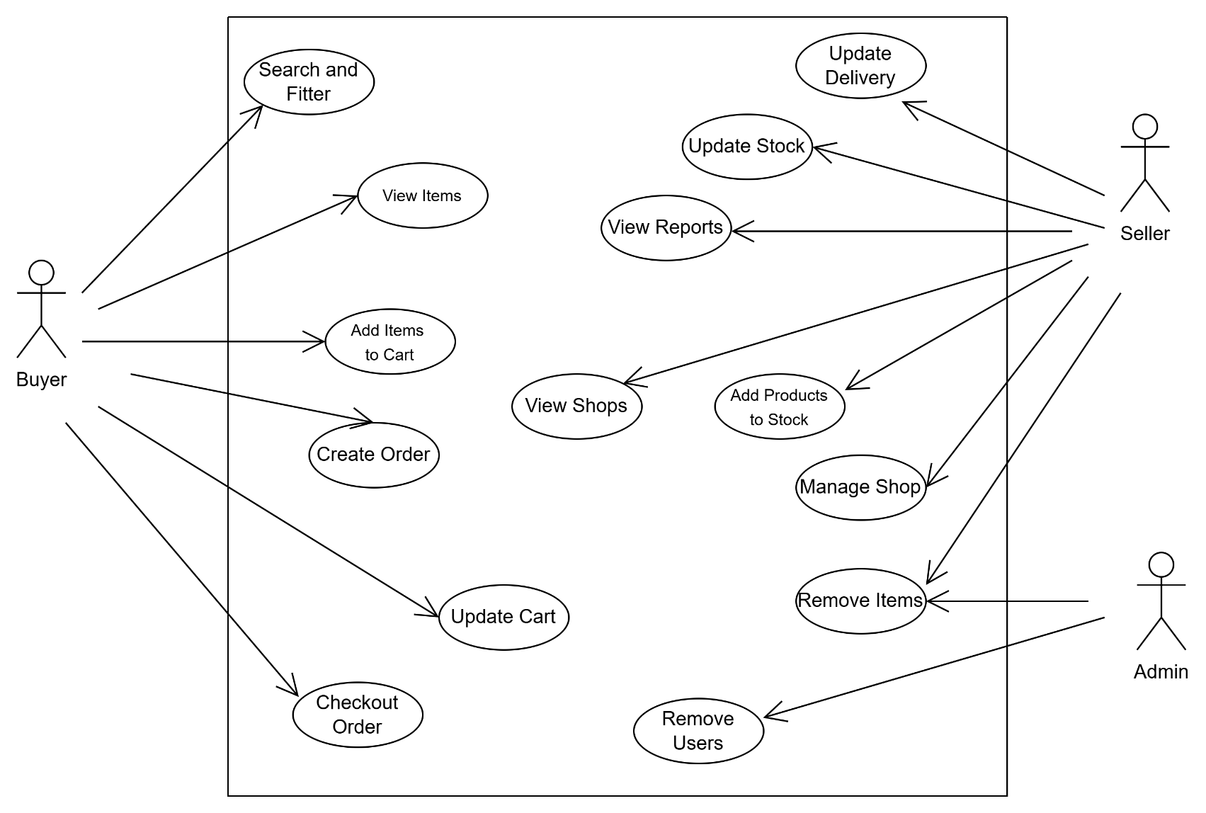

**Class diagram**

**State diagram**

**Sequence diagram**

